Chapter 11, Solution 54.

For the network in Fig. 11.73, find the complex power absorbed by each element.

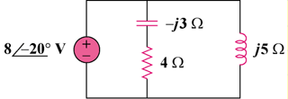

Figure 11.73
For Prob. 11.54.

Solution

Consider the circuit shown below.

For the source,
(10.24+j3.12) VA

For the capacitor,
–j7.68 VA

For the resistor,
10.24 VA

For the inductor,
j12.8 VA

